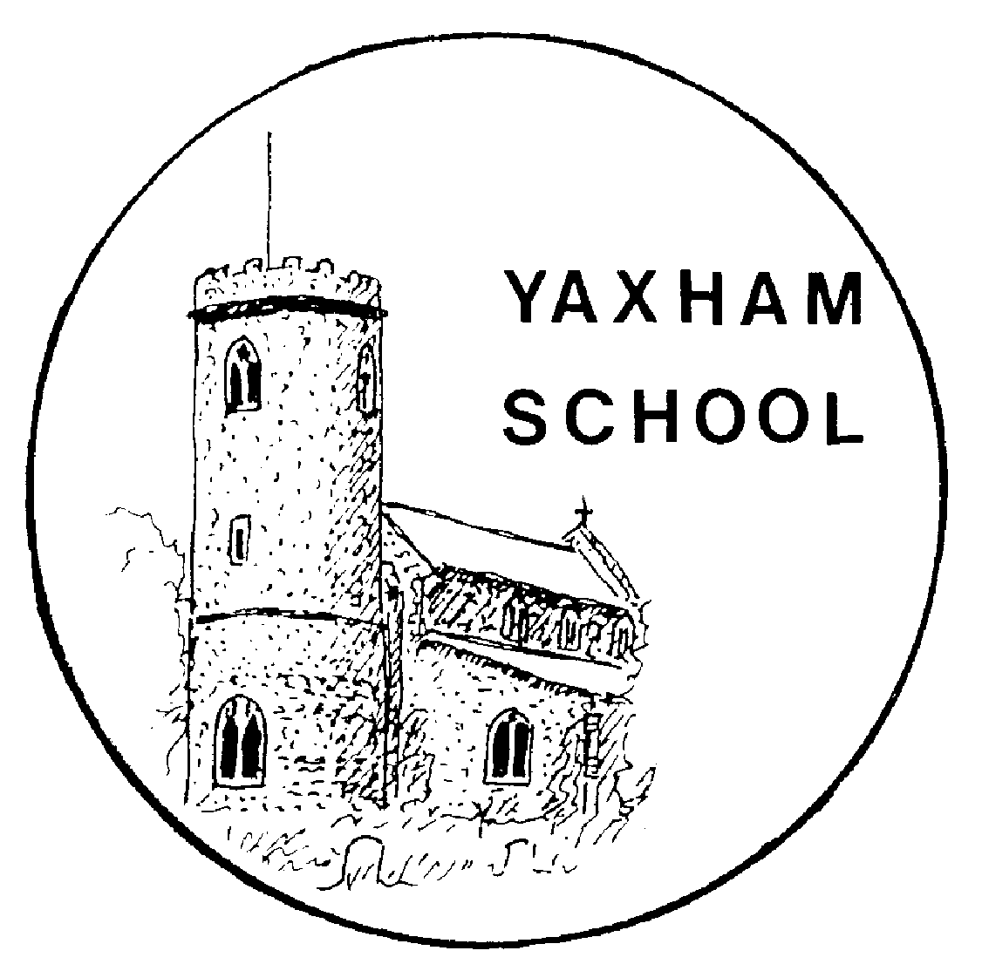

Religious Education Policy

“Recognising its historic foundation, the school will preserve and develop its religious character in accordance with the principles of the Church of England and in partnership with the Church and Parish at diocesan level.

The school aims to serve its community by providing an education of the highest quality within the context of Christian belief and practice. It encourages an understanding of the meaning and significance of faith and promotes Christian values through the experience it offers to all its pupils.”

Policy Consultation & Review

This policy is available on request from the school office. It will be reviewed in full by the Governing Board every three years. This policy was last reviewed and agreed by the Governing Board on 22nd May 2019 It is due for review in May 2022.

Signature: Jennie Müller Headteacher Date: 22nd May 2019

Signature: Claire Sullivan Chair of Governors Date: 22nd May 2019

RE Policy Statement

Religious education is unique in the school curriculum in that it is neither a core subject nor a foundation subject. The 1988 Education Act states that ‘Religious Education has equal standing in relation to core subjects of the National Curriculum in that it is compulsory for all registered pupils’. As a school we follow the principles of the Locally Agreed Syllabus for Religious Education (Norfolk/Suffolk) and supplement this with material from the Diocese.

Aims

The broad aims of religious education (RE) are set out within the locally agreed syllabus and the Church of England Education Office Statement of Entitlement (2016). The purpose of religious education is to promote religious literacy. Pupils should be able to hold balanced and well-informed conversations about religion and belief.

The aims of religious education are to enable pupils to:

- Know about and understand Christianity as a living faith that influences the lives of people worldwide and as the religion that has most shaped British Culture and heritage.
- Give a theologically informed and thoughtful account of Christianity as a living and diverse faith.
- Know about and understand other major world religions and world views, their impact on society, culture and the wider world, enabling pupils to express ideas and insights.
- Show a well-informed, balanced and respectful attitude to religions and world views
- Engage in meaningful and well-informed dialogue with those of other faiths and none
- Reflect critically and responsibly on their own spiritual, philosophical and ethical convictions, exploring and enriching their own beliefs and values.

Curriculum

The curriculum for RE is designed to ensure religious literacy lies at the heart. A multi-disciplinary approach to curriculum design provides a balance between theology, philosophy and the human/social sciences.

Theology:
This examines where beliefs come from, how they have changed over time, how they are applied differently in different contexts and how they relate to each other.

Philosophy:

This is about finding out how and whether things make sense. It deals with questions of morality and ethics. It takes seriously questions about reality, knowledge and existence.

Human/Social Sciences:
This explores the diverse ways in which people practice their beliefs, both now and in the past. It engages with the impact of beliefs on individuals, communities and societies.

These three disciplines provide lenses through which each enquiry question is approached.

In accordance with the structure of the locally agreed syllabus we have agreed that:

- At KS 1 pupils study primarily Christianity and Judaism, with reference made to other principal religions, beliefs and worldviews.

- At KS 2 pupils study primarily Christianity, Islam and Hinduism, with reference made to other principal religions, beliefs and worldview.

In accordance with the Statement of Entitlement (2016), 2/3 curriculum time is allocated to the teaching of Christianity. This entitlement is met both through the weekly or blocked teaching of RE, and through additional RE days.

The use of the resource Understanding Christianity particularly supports the development of the theological perspective.

Teaching RE

Religious education uses an enquiry-based approach to learning. This is based on the best practice framework in the Norfolk/Suffolk agreed syllabus. This approach enables pupils to focus on an enquiry question which explores aspects of the theological, philosophical and human/social sciences. A range of teaching strategies are used to ensure learning is challenging and relevant including the use of art, music, thinking skills, artefacts and stories.

Where possible our children will have opportunities to encounter local faith communities through visits to local places of worship or visit from members of local faith communities.

Assessment

Pupils are assessed in terms of how they are making progress in relation to the theological, philosophical and human/social sciences disciplines within RE. In broad terms the following principles have been applied to each aspect in terms of what it means to become more religiously literate:

- Extending knowledge and understanding from the concrete and familiar to the abstract and complex
- Moving from simple ideas and beliefs/concepts to making connections between them and placing these within a bigger picture or meta-narrative
- Demonstrating increasing layers of interpretation of religion, religions, beliefs and worldviews through engagement with a broadening and increasingly complex range of information
- Showing an increasing ability to critically question and form coherent, logical arguments, including increasing recognition of divergences of opinion about and the controversial nature of religion and belief
- Expressing a broadening understanding of diversity in terms of the nature of religion, religions and worldviews

Pupils are assessed using age-related expectations. This is done in a variety of ways e.g. through written activities, role play, art work, discussion.

Assessment is regarded as an integral part of teaching and learning and is a continuous process. It is the responsibility of the class teacher to assess all pupils in their class. We assess the children in order to ensure that they make good progress in this subject and to plan future work.

In addition, pupils are encouraged to use self-assessment to evaluate their own knowledge and understanding. A comment about their progress is made in the annual report to parents.

Monitoring & Evaluation

The co-ordinator will monitor RE provision and standards through observation, looking at work, talking to children and reviewing the curriculum with staff.

The co-ordinator is responsible for contributing to the school’s self-evaluation process. In addition, the governing body monitor the role of religious education and its contribution to the Christian ethos of the school.

Responsibilities for RE

The Governing Board and head teacher should ensure sure that:

- All children make progress in achieving the aims of the RE curriculum
- The subject is well led and effectively managed
- Standards and achievement in RE and the quality of the provision are subject to regular and effective self-evaluation
- Those teaching RE are suitably qualified and trained in the subject and have regular and effective opportunities for CPD
- Clear information is provided on the school website about the RE curriculum
- RE is resourced, staffed and timetabled so that the School can fulfil its legal obligations on RE and children can make good progress
- Where there are insufficient teachers within the school who are prepared to teach RE, the head teacher will ensure that children receive their entitlement to RE.

The Right of Withdrawal From RE

Yaxham CE VA Primary School is an inclusive community. We recognise that parents have the legal right to withdraw their children from religious education on the grounds of conscience. However, the right of withdrawal does not extend to other areas of the curriculum when, as may happen on occasion, spontaneous questions on religious matters are raised by pupils or there are issues related to religion that arise in other subjects such as history.

We would ask any parent considering this to contact the headteacher to discuss any concerns or anxieties about the policy, provision and practice of religious education.

Managing the right of withdrawal

- Yaxham CE VA Primary School will ensure that parents who want to withdraw their children from RE are aware of the RE syllabus and that it is relevant to all pupils and respects their own personal beliefs.
- Parents should be made aware of its learning objectives and what is covered in the RE curriculum and should be given the opportunity to discuss this, if they wish.
- The school will review such a request each year, in discussion with the parents.
- The use of the right to withdraw should be at the instigation of parents, and it should be made clear whether it is from the whole of the subject or specific parts of it. No reasons need be given.
- Parents have the right to choose whether or not to withdraw their child from RE without influence from the school, although as a school we will ensure that parents or carers are informed of this right and are aware of the educational objectives and content of the RE syllabus. In this way, parents can make an informed decision.
- If children are withdrawn from RE, the school has a duty to supervise them, though not to provide additional teaching or to incur extra cost. Children will usually remain on the school premises.
- Outside arrangements for RE are allowed as long as the LA is satisfied that any interference with the child’s attendance resulting from the withdrawal will affect only the start or end of a session.

Role of the RE Leader

- To ensure that the RE policy is implemented and to keep up to date with reviews.
- To have oversight of the RE curriculum and keep up to date with local and national changes.
- To monitor, review and update resources.
- To monitor progress and achievement.
- To develop links with the Church and Diocese.
- To coach, mentor and support teachers in developing their strengths in teaching RE, including planning, arranging and delivering CPD as appropriate.
- To liaise with parents to ensure all children receive their entitlement.

Inclusion

All children are entitled to access a broad and balanced curriculum at an appropriate level. Teachers should include a range of teaching styles and groupings to allow all children to make progress. Every child should be given opportunity to develop their skills independently and in groups, enhancing their own confidence and self–esteem.

Resources

The school has a wide range of resources to support the teaching of RE. Additional resources are also available centrally at the Diocesan Resource Centre.

The contribution RE makes to other curriculum aims

Spiritual, moral, social and cultural development
Section 78 (1) of the 2002 Education Act states that all pupils should follow a balanced and broadly based curriculum which ‘promotes the spiritual, moral, cultural, social, mental and physical development of pupils and of society, and prepares pupils for the opportunities, responsibilities and experiences of later life’. Examining and exploring religions and beliefs, through the distinct knowledge, understanding and skills contained in RE, is essential to achieving these aims. Exploring the concepts of religion and belief and their roles in the spiritual, moral and cultural lives of people in a diverse society helps individuals develop moral awareness and social understanding.

Personal development and well-being
RE plays an important role in preparing pupils for adult life, employment and lifelong learning. It helps children and young people become successful learners, confident individuals and responsible citizens. It gives them the knowledge, skills and understanding to discern and value truth and goodness, strengthening their capacity for making moral judgements and for evaluating different types of commitment to make positive and healthy choices.

Community cohesion
RE makes an important contribution promoting community cohesion. It provides a key context to develop young people’s understanding and appreciation of diversity, to promote shared values and to challenge
racism and discrimination. Effective RE will promote community cohesion at each of these four levels.

The School community
RE provides a positive context within which the diversity of cultures, beliefs and values can be celebrated and explored.

The community within which the School is located
RE provides opportunities to investigate patterns of diversity of religion and belief and forge links with different groups in the local area.

The UK community
Aa major focus of RE is the study of diversity of religion and belief in the UK and how this influences national life.

The global community
RE involves the study of matters of global significance recognising the diversity of religion and belief and its impact on world issues.

RE subject matter gives particular opportunities to promote an ethos of respect for others, challenge stereotypes and build understanding of other cultures and beliefs. This contributes to promoting a positive and inclusive school ethos that champions democratic values and human rights.

Monitoring & Review

The implementation and impact of the policy will be evaluated through the School’s self-evaluation processes. The policy will be reviewed every three years.

Yaxham CE VA Primary School would like to acknowledge the work of the Diocese of Norwich Education and Academies Trust upon whose guidance this policy is based.

