Art & Design

- Fire pictures using tissue paper and pastels.
- Design and build Tudor house models.
Literacy

- Samuel Pepys diary
- Writing our own diary entries.
- Recount of the events.

Science/Geography/ History

- Events leading up to the Great Fire of London
- Materials that burn.
- How to put out fire.
- Fire safety
- London – where is it?

Music & Drama

- Re-enacting the events of the Great fire of London.
- Access to classroom role-play area. Dress up and play in the Tudor bakery.
The Great Fire of London
Puffins Class
Autumn 1
.
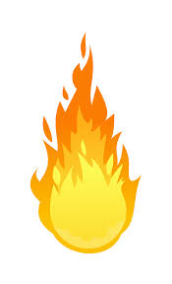
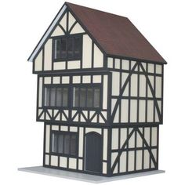
2018/19 .
Personal. Social & Emotional

- Mindfulness skills – understanding how our brains work.
- Teamwork
- Fire safety
Special Experiences:
- Visit from the fire service.
- Re-enacting how the Great Fire of London happened – setting fire to and extinguishing the Tudor models we have built.

