 Yaxham Church of England (VA) Primary School

Clint Green, Yaxham, Dereham, Norfolk, NR19 1RU

Tel. 01362 692033

e-mail: [office@yaxham.norfolk.sch.uk](mailto:office@yaxham.norfolk.sch.uk)

[www.yaxhamprimaryschool.co.uk](http://www.yaxhamprimaryschool.co.uk)

Headteacher: Mrs Jennie Müller

Chair of Governors: Mrs Michelle Parnell

21st July 2020

Dear Parents,

As the strangest year in school history draws to a close, we wanted to take this opportunity to thank you for the incredible level of support you have shown us this year. Your children have been so lucky to have parents who have adapted so well to the situation, the home learning has been nothing short of outstanding. I am sure you are all looking forward to the holiday more than ever before!

You will have received class letters which gave some information about September. Please do remember this is all subject to change, we are expecting the final government update in the middle of August. This will allow governors to review our risk assessment and plans before children return to school. You will find below details of our current plan to help you prepare. (Please note that the class times may be different to the class information, sorry for this mistake!)

As always we have tried to make our plans in the best interest of everyone. The guidelines are very clear that contact between adults needs to be kept to a minimum so staggered times will remain for the foreseeable future. Adults in school will also need to maintain a distance from children, classroom layout and other procedures will reflect this.

Children will be based back in class groups. Furniture will be rearranged to ensure children face the front of the room, rather than each other. (This will be slightly different for our youngest children in Hedgehogs.) Teachers will share photographs of the classrooms on Tapestry on Friday 4th September so that the children know what to expect when they join us on Monday 7th September.

**Classes**

* Children will be in their own class groups.
* They will remain in their class with the same staff (the class teacher and a teaching assistant) and children.
* Badgers and Foxes will have lunch in their classroom, Hedgehogs and Squirrels will eat in the hall. This will be pack lunch only initially. We hope to add hot food later in the term.
* A lunch time supervisor will join them; this will be a member of staff assigned to that class.
* Each child will have their own space. Resources will be put in those spaces so that they will not need to share. All toys and soft furnishings that cannot be washed easily at the end of the day have been removed.
* Equipment that they use will be cleaned daily and tables and other touch points at the beginning and end of lunch. All rooms will be cleaned at the end of the day.

Proposed Start/finish times:

|  |  |  |  |
| --- | --- | --- | --- |
| Class | Start of day | End of day | Entrance |
| Hedgehog | 8.55 | 3.15 | Front Gate (from 8.50) |
| Squirrel | 8.55 | 3.15 | Back Gate (from 8.50) |
| Badger | 8.45 | 3.05 | Front Gate (from 8.40) |
| Fox | 8.45 | 3.05 | Back Gate (from 8.40) |

The proposed times will not change the length of children’s time in school but will support us in keeping the number of adults on site to a minimum. Gates will open 5 minutes before the start time and children and will go straight into the classroom to prepare for the school day. It is really important that children arrive promptly and do not cross over with other classes.

Hedgehog and Squirrel class will join as a bubble and Badger and Fox class will make a second bubble. This will allow staff to support across the two classes.

**General operation**

* Children will be expected to wear school uniform.
* Children will need a clean pair of indoor shoes or slippers to change into. (Plimsolls/crocs are suitable alternatives)
* Children will not be able to bring in anything from home except a water bottle and their lunch box.
* Children should not bring reading records, pencil cases, PE kits or any other items. The children will not need bags in school.
* A collection of reading books will be sent home on a Monday and can be returned on Friday. They will not be changed in between.
* If children fall over or have a toileting accident the children will be encouraged to change themselves and clean their scrape or cut. Any further first aid we will make the judgment about what is necessary but at the least staff will wear gloves and a face mask where they need to be in close contact to treat injuries.
* Children can leave a bag with a change of clothes in school if you think they are likely to need them.
* Parents will be notified of first aid treatment by text.
* We have PPE (following the Covid 19 guidance for educational setting) which is for use only for protection for extreme illness or caring for children displaying symptoms of Covid-19. In these situations, parents will be contacted immediately and the child must be collected from school as soon as possible.
* If children show any symptoms such as a cough or high temperature they must stay at home.
* Do not use Calpol/Paracetamol to mask symptoms. If anyone displays these symptoms they will need to go home immediately and will need to be tested. Any positive test would lead to the whole group needing to be isolated for 14 days.
* We must ask you to respect our whole community and keep to government guidance in and out of school, for the sake of everyone’s well-being.
* The office will continue to be closed for unplanned visits. We will not accept cash. All payments will need to be made bank transfer. Details of how to do this will be shared upon request.
* Please do not enter the reception area, if you need to speak to the school office, please telephone.

**Drop off and pick up**

* Children will arrive to school in the morning and be picked up in the evening at specified times. This is to minimise the numbers of people on the site at any one time. 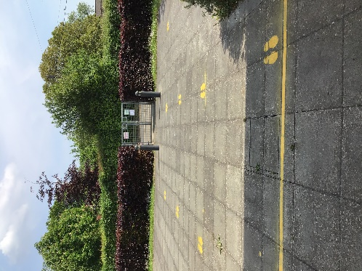
* Only one adult per family will be admitted to the site for drop off and collection of children
* If you have children in different classes, you cannot bring the other child with you to collect from another class. If you are not able to make arrangements for this, please telephone the school office so that alternative arrangements can be made.
* Hedgehogs and Badgers will enter through the front gate and door. (These are the gates which are normally locked)
* 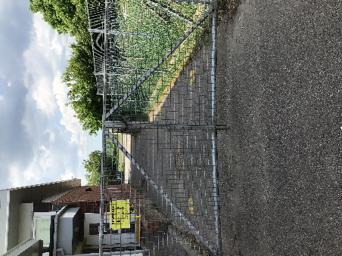Squirrels and Foxes will enter through the back playground and classroom doors.
* The playground has been marked out with a direction of travel with 2m intervals. Along the fence on the pavement, we have continued to mark 2m distancing whilst you are awaiting to enter school.
* Class teachers will be at the door, you can drop your child off at the drop off point and to leave the school site.
* Please do not stop to chat with either staff or fellow parents. Leave the site as quickly as possible.

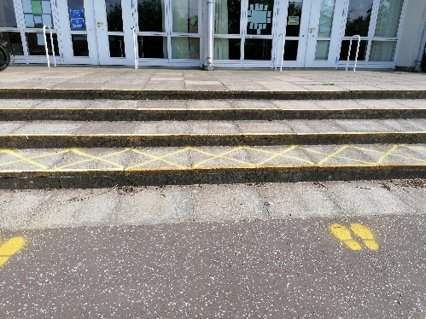

* At the end of the day, collection times have been allocated, parents will need to stand on the 2m distancing signs and children will be sent to you one at a time.
* Parents are not allowed to enter the school building or have the daily contact or conversations they need or are used to having with staff. Contact will continue to be email or telephone
* Please try not to be late. If you are you will need to wait, telephone the office and arrange a new time.
* If you are using a childminder or breakfast/after school club, please let us know
* We will not be running any after school clubs initially.

**Morning club**

Morning club is able to run in the hall with bubbles divided in opposite areas of the hall, each bubble will have its own equipment. Places are limited to a maximum of 15 children, therefore we ask you to book places a week in advance. Booking forms will be shared before the start of term. Payment will need to be made by bank transfer.

**Break times and lunch times**

* Children bringing home packed lunch ideally any packaging should be entirely disposable – to avoid carrying items backwards and forwards to school. Lunchboxes must be clean and washable.
* School packed lunches will be available to order by email or telephone.
* Outside play equipment like the trim trail will not be able to be used initially but each bubble will have their own collection of washable equipment which will be cleaned after use.

**Toilets**

Each bubble will have allocated toilets, with only one child using them at a time. These will be cleaned during the day.

**Learning**

* Children have worked brilliantly at home but teachers have not been able to assess accurately while they haven’t been in school. They will very quickly assess where children are when the return and plan accordingly.
* The curriculum will continue to have some modification for health and safety reasons, such as PE and Music activities.
* We will need to encourage more independence in school but they will still have support.
* Children will need to be able to fasten their own clothes and shoes. If they have shoe laces they do need to be able to tie them independently.
* Should there be reason to close a class/bubble and children are asked to self-isolate, the school will provide home learning.

Once children are in school we will know how successful our plans are and we will adapt as necessary. We will review regularly. We continue to work on the risk assessments and plans. We will of course inform you of any significant changes.

As always, we really appreciate your ongoing support and understanding. We will do all we can to work with you to keep our children and community safe whilst settling all children back into school. Please do get in touch if you have any concerns or questions.

We wish you a relaxing summer break and look forward to welcoming all children back into school in September.

Yours sincerely,

Mrs Jennie Müller and Mrs Michelle Parnell

Headteacher Chair of Governors