TEXT 3 -Alfred The Great
Stories about Alfred the Great “In the year of the Lord's incarnation 849, ‘Alfred, King of the Anglo-Saxons’, was born at the royal estate called Wantage in the district known as Berkshire. King Alfred was the son of Aethelwulf. Alfred's mother was called Osburh; a most religious woman, noble in character and noble by birth.” That's how the monk Asser records the birth of Alfred, the Saxon child who would grow up to lead the fight against the Vikings, promote learning throughout the kingdom he ruled, and try to unite the Anglo-Saxons as one people – the English. And because Asser wrote the biography, Alfred is one of the few Anglo-Saxon children we know something about.
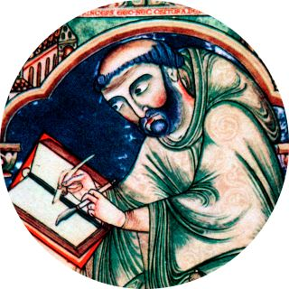
According to Asser, learning was something which fascinated Alfred, even when he was very young. Asser tells the story of a book, which was given to Alfred by his mother. “One day when his mother was showing him and his brothers a book of English poetry which she held in her hand. She said… ‘I shall give this to which one of you can learn it the fastest.’ Spurred on by these words, or rather by divine inspiration, and attracted by the beauty of the initial letter in the book, Alfred spoke as follows in reply to his mother. ‘Will you really give this book to the one of us who can understand it the soonest and recite it to you?’ Where-upon, smiling with pleasure, she reassured him, saying… ‘Yes, I will.’ He immediately took the book from her hand, went to his teacher and learned it. When it was learned, he took it back to his mother and recited it.” It doesn't say Alfred read the book. It says he learned it.
In Anglo-Saxon times, that’s how children were educated by memorising things. Memorising and reciting poetry was a very popular activity for Anglo-Saxons. Books were incredibly rare, so there wasn't much need for people to read. When Alfred finally did learn to read at the age of 12, he wasn’t taught in a school he was taught by a tutor.
In Anglo-Saxon times, there were few schools in England, and only a handful of people went to them. The first schools were established in the 6th or 7th century. They were attached to churches and monasteries, and trained boys and girls for the religious life. They learned to read and write in Latin, studied music and religious writings.
Anglo-Saxon times, in many ways, were very good times to be a girl. Although very few boys and girls were educated in the religious schools, the Anglo-Saxons believed that it was just as important for girls to be educated as it was for boys. Alfred's children, boys and girls, all learned to read and write. Learning from a book was only part of Alfred's education as a child. Any noble boy in Anglo-Saxon times was expected to learn the skills he would need as an adult in battle.
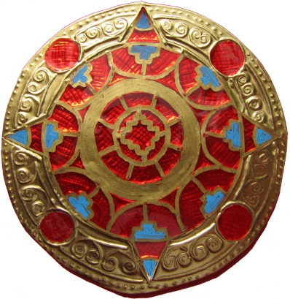
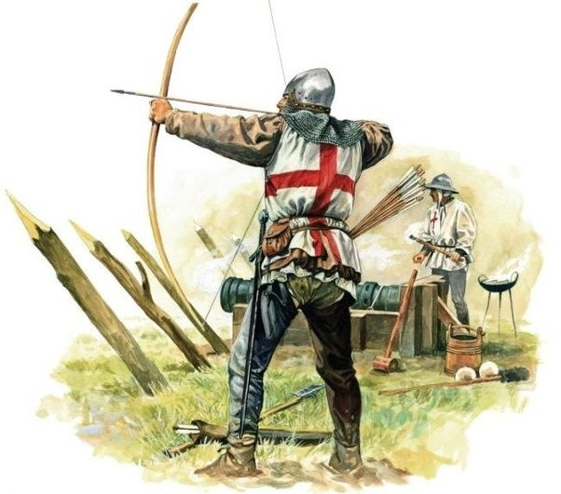
Alfred was expected to grow up to fight, and to rule with kindness and justice. Many of the skills he would need to do this were physical, so much of his childhood was spent in outdoor activities like archery and sword fighting.

