English  - Recount writing  - Biography  - Historic narratives  SPAG  Focussing on all features throughout the week to ensure consistency and fluency  - Adjectives, nouns and expanded noun phrases  - Verbs and adverbs  - Sentence types - statements, questions, exclamations and commands  - Apostrophes, commas and contractions  - Homophones and tenses  - Prefixes and suffixes  - Subordination and coordination | Spring 1  Explorers  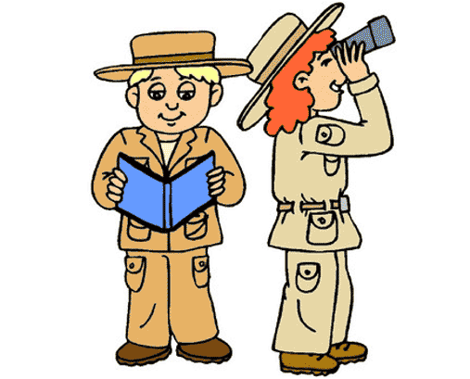 | Maths  - Multiplication and division  - Times tables  - Doubling  - Odd and even numbers  - Tally charts, block diagrams and pictograms
History
- Learning about explorers who are famous globally and locally

Geography
- Locating places that different explorers throughout time explored
- Locating countries all around the world

Science
- What materials would be best for floating?
Art and DT  - Designing and making 3d structures  - Designing different modes of transport for exploring  - Listening to exploration stories and creating images based on the descriptive language | Homework  Set weekly on Tapestry consisting of -  - Weekly spellings  - 1 writing or math activity  - Reading | Spanish  - Animals  - Food items  - Simple conversations
 | RE  - What is the good news that Jesus  brings? | PE  - Real PE  - Gymnastics
Music  - History of music and music from different traditions | PSHE and RSE  - Relationships | ICT  - E-Safety  - Recording sound and creating a video

