English  - Recounts  - Fiction and non-fiction  - Poetry  SPAG  Focussing on all features throughout the week to ensure consistency and fluency  - Adjectives, nouns, verbs and adverbs  - Sentence types - statements, questions, exclamations and commands  - Apostrophes, commas and contractions  - Homophones and tenses  - Prefixes and suffixes  - Subordination and coordination | Spring 2  The Seaside  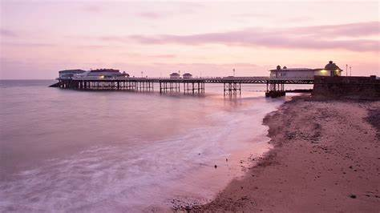 | Maths  - 2d and 3d shapes  - Symmetry  - Fractions
History
- Changes from Victorian era to present

Geography
- Locating beaches

Science
- Seasonal changes – Spring
- Rocks and soils
Art and DT  - Sewing  - Easter crafts | Homework  - Weekly spellings  - 1 writing or math activity  - Reading | Spanish  - Family members  - Simple conversations
 | RE  - Lent  - Easter | PE  - Real PE  - Gymnastics
Music  - Games, singing and listening to dimensions of music (pulse, rhythm, pitch, etc) centred on a reggae song. | PSHE and RSE  - My beliefs  - Differences and similarities between people and family units | ICT  - E-Safety  - Digital Literacy – typing, saving work, copying and pasting, resizing images

